Hotels on Canyon
Boulder, CO

Project Details
Description: 204-room Embassy Suites
172-room Hilton Garden Inn
Owner: Sala LLC / Shames Makovsky
Architect: JNS Architecture
General Contractor: Milender White Construction
Budget: $121MM
Completion: 2018

Project Description
Embassy Suites
The Hotels on Canyon was the development of a full city block at the corner of Canyon Blvd and 28th Street in Boulder Colorado. The project, which included the construction of a 2-level underground parking garage, two new hotels, and a development pad for a new office building, was developed by Shames Makovsky Realty in partnership with LJD Enterprises.
Scope of Services
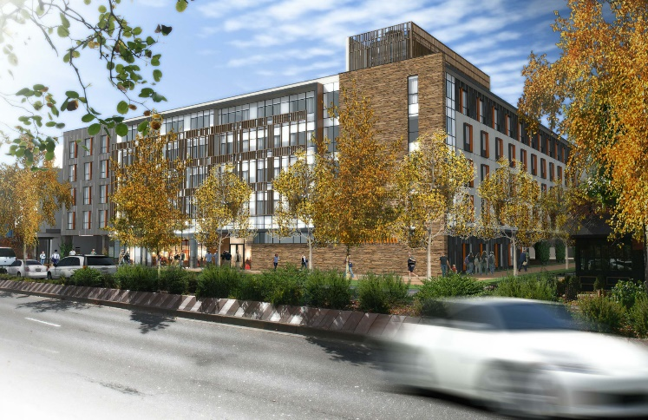
SII partnered with Barry Gilbert to deliver project management services to Shames Makovsky Realty. Barry was responsible for oversight of the design and construction team, and SII provided the following project controls services:

- Developing and managing phased budgets, including daily oversight of invoice processing, exposure tracking, contingency administration, cash flow reforecasting, and lender relationship management.
- Worked with ownership to develop specialized reporting tools for communication with investors, lenders, development partners, and to aid the value engineering and decision-making processes.
- Coordinated all FF& procurement with specialized hospitality logistics company.

